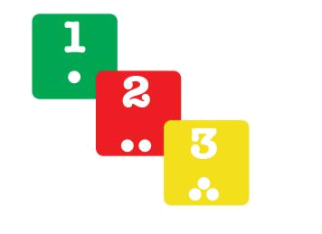
MOVEMENT DICE
A game to explore movement with young movers
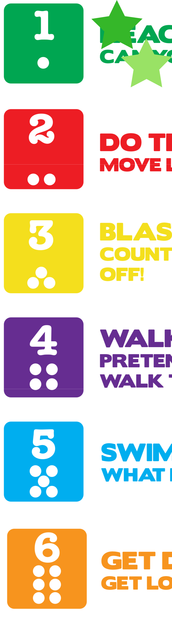

REACH FOR THE STARS

CAN YOU REACH ONE?
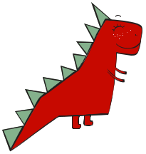

DO THE DINO STOMP!

MOVE LIKE A DINOSAUR


BLAST OFF!

COUNTDOWN FROM 5 & JUMP TO BLAST OFF!


WALK THE PLANK!

PRETEND TO BALANCE ON A LINE & WALK THE PLANK
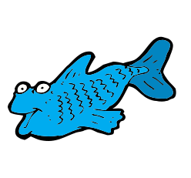

SWIM LIKE A FISH!

WHAT KIND OF FISH ARE YOU?


GET DOWN... GET UP!

GET LOW & GET UP 5 TIMES


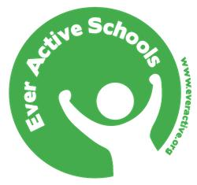

befitforlife.ca/resources everactive.org/resources

